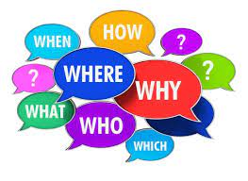

Key Questions:

- Is faith relevant?
- Why is faith relevant?
- Does my life interact with faith?
- Is faith really in everything?
- How is faith hidden?
- Why has faith become hidden?
- Has faith fallen out of favour?
- What is the impact of hiding faith on faith communities? How can worldviews and faith shape your life experiences?

Key Words

Faith | Complete trust or confidence in  someone or something.
Atonement | The action of making amends for a  wrong or injury.
Religion | The belief in and worship of a  superhuman power or powers,  especially a God or gods.
Icon | An icon is a religious work of art, most  commonly a painting, in the cultures  of the Eastern Orthodox, Oriental  Orthodox and Catholic churches
Madonna | The Virin Mary, mother of Jesus
Secular | Not connected with religious or  Spiritual matters.
Revelation | A surprising and previously unknown  fact that has been disclosed to others.
Yahweh | A form of the Hebrew name of God  used in The Bible. The name came to  be regarded by Jewish people as too  sacred to be spoken.
Bishop | A senior member of the Christian  Clergy usually in charge of a diocese.
Humility | The quality of having a modest or low  view of one's importance.
Service | The action of helping or doing work  for someone.
Incarnation | A central Christian teaching that God  Became flesh, that God became man  in the form of Jesus Christ.
Sunday | The day of the week before Monday  and following Saturday, observed by  Christians as a day of rest and  religious worship.

Y9 Unit Title: How visible are religious beliefs and worldviews?

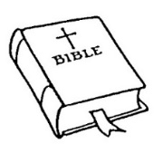

Religious Texts from
The Bible for you to explore:

- Genesis 1 & 2,
- Isaiah 11: 6
- Matthew 1:18 – 2:1-12
- Luke 1:26 -38, 2: 1-20

